**MERCHANT ONBOARDING FORM**

|  |  |  |  |  |  |  |  |  |  |  |  |
| --- | --- | --- | --- | --- | --- | --- | --- | --- | --- | --- | --- |
| **SECTION I: DETAILS OF MERCHANT** | | | | | | | | | | | |
| 1. Type of Business |  | Sole Proprietor | |  | Partnership | | |  | | Corporation | |
|  | Government Entity | |  | Non-Profit Org. | | |  | | Others: | |
| 1. Company Registered Name |  | | | | | | | | | | |
| 1. Company Registration No. |  | | | | | | | | | | |
| 1. Domain Name | https:// | | | | | | | | | | |
| 1. Company Registered Address |  | | | | | | | | | | |
| 1. Company Business Address |  | | | | | | | | | | |
| 1. Merchant Type |  | Direct Merchant | |  | Sub-Merchant | | | |  | |  |
| *Details of Master Merchant/ Referrer* | | Name: | | | | | | | | |
| 1. Merchant Category |  | Small Enterprise   1. *Manufacturing sector: Sales turnover from RM300,000 to less than RM15 million OR full-time employees from 5 to less than 75* 2. *Services & other sectors: Sales turnover from RM300,000 to less than RM3 million OR full-time employees from 5 to less than 30* | | | |  | Medium Enterprise   1. *Manufacturing sector: Sales turnover from RM15 million to not exceeding RM50 million OR full-time employees from 75 to not exceeding 200* 2. *Services & other sectors: Sales turnover from RM3 million to not exceeding RM20 million OR full-time employees from 30 to not exceeding 75* | | | | |
|  | Microenterprise  *Across all sectors: Sales turnover of less than RM300,000 OR less than 5 full-time employees.* | | | |  | Corporate  *Other than Small, Medium & Microenterprise* | | | | |

|  |  |  |
| --- | --- | --- |
| **SECTION II: NAME OF DIRECTOR/ PARTNERS** | | |
| Director / Partner Name: | NRIC/ Passport No.: | Contact No.: |
|  |  |  |
|  |  |  |
|  |  |  |
|  |  |  |

|  |  |  |  |
| --- | --- | --- | --- |
| **SECTION III: NAME OF AUTHORISED PERSON** | | | |
| Employee(s) Name: | NRIC/ Passport No.: | Email Address: | Contact No.: |
|  |  |  |  |
|  |  |  |  |

|  |  |  |  |
| --- | --- | --- | --- |
| **SECTION IV: MERCHANT BANK ACCOUNT INFORMATION** | | | |
| 1. Bank Name: |  | 1. Account No: |  |
| 1. Beneficiary Name: |  |  |  |

*Note: The beneficiary of the account has to be the same name of the company, or business, registered with us . Company will not be paying into any other account other than those stated above. If there is any change to the account details, please provide advance written notice in accordance with the Merchant Terms.*

|  |
| --- |
| **SECTION VI: TERMS AND DECLARATION** |

* 1. Unless expressly set out in this Merchant Onboarding Form, all capitalised words not defined herein shall have the same meaning ascribed in the Merchant Terms found within [www.kiplepay.com](http://www.kiplepay.com) (“kiple Website”). This Merchant Onboarding Form and its Schedule shall be incorporated and form part of the Merchant Terms.
  2. In the event of a conflict or inconsistency between the provisions of this Merchant Onboarding Form and other provisions of the Merchant Agreement, the provisions of this Merchant Onboarding Form shall prevail to the extent of such inconsistency.
  3. I/We agree to the following: -

1. all the information provided in this Merchant Onboarding Form is accurate and complete; and
2. We have read, understand and agree to be bound by the Merchant Terms found within kiple Website.

**SIGNED FOR AND ON BEHALF OF MERCHANT BY**

*Company stamp*

Name:

Designation:

NRIC/ Passport No.:

Date:

|  |  |
| --- | --- |
| **FOR KIPLE OFFICE USE ONLY** | |
| Date Received:  Remark: | |
| Processed By  Name:  NRIC/ Passport No.:  Designation: | Approved By  Name:  NRIC/ Passport No.:  Designation: |

**SCHEDULE I**

**DETAIL OF SERVICES**

|  |  |  |  |  |  |  |  |  |
| --- | --- | --- | --- | --- | --- | --- | --- | --- |
| **SERVICES** | **Payment Gateway** | | | | | | | |
|  | FPX Online Payment (B2C) | | |  | FPX Online Payment (B2B) | | |
|  | Local Credit Card | | |  | Foreign Credit Card | | |
|  | Local Debit Card | | |  | Kiple Wallet | | |
|  | WeChat Pay1,2 | | |  | AliPay1,2 | | |
|  | Boost1,2 | | |  | Touch 'n Go1,2 | | |
|  | GrabPay1,2 | | |  | UnionPay1,2 | | |
|  | MayBank QR Pay1,2 | | |  | ShopeePay1,2 | | |
|  | WeChat Pay QuickPay (MY) 1,2 | | |  | One Click Payment | | |
|  | Recurring | | |  | Pre-Auth & Capture (3DS) | | |
|  | Pre-Auth & Capture (Non-3DS) | | |  | Others: | | |
| **E-Wallet** | | | | | | | |
|  | Kiple Wallet | | |  | Boost1,2 | | |
|  | Touch 'n Go1,2 | | |  | GrabPay1,2 | | |
|  | AliPay (CN) 1,2 | | |  | WeChat (CN)1,2 | | |
|  | WeChat Pay QuickPay (MY) 1,2 | | |  | Maybank QR Pay1,2 | | |
|  | ShopeePay1,2 | | |  | UnionPay1,2 | | |
|  | Local Debit Card (Link & Pay) | | |  | Local Crebit Card (Link & Pay) | | |
|  | Kasih Ibu Smart Selangor | | |  | Perak Prihatin | | |
|  | Kasih Ibu Darul Aman | | |  | Others: | | |
| *Complete Appendix A.* | | | | | | | |
| **Card Acceptance Device (CAD)3** | | | | | | | |
|  | Local Debit Card | | |  | Local Credit Card | | |
|  | Foreign Debit Card | | |  | Foreign Credit Card | | |
| *Complete Appendix A* | | | |  |  | | |
| **CHARGEBACK FEE** | Chargeback fee of 5.5% of the transaction value will be applied for each chargeback request.  Reversed fee of RM2.00 will be applied for each successful defended or reversed chargeback. | | | | | | | |
| **SETTLEMENT PROCESS** |  | | | | | | | |
| **PACKAGES** |  | Basic |  | Bronze |  | Silver |  | Gold |
|  | Platinum |  | Others: | | |  |  |
| **EQUIPMENT** | Refer to Schedule II Section II | | | | | | | |
| **KIPLEPAY CUSTOMER SUPPORT DETAILS** | [support@kiplepay.com](mailto:support@kiplepay.com) or 603-8605 3357 | | | | | | | |
| **FINANCE SUPPORT TEAM EMAIL** | [finance@kiplepay.com](mailto:finance@kiplepay.com)  *only if Customer Support cannot handle and only if there is a dispute on the Settlement.* | | | | | | | |

**SCHEDULE II**

**CHARGES SCHEDULE**

|  |  |  |
| --- | --- | --- |
| **SECTION I: ONBOARDING FEE** | | |
| **Type of Fee** | **Amount (RM)** | **Remark** |
| One Time Setup Fee: |  |  |
| Annual Renewal Fee4: |  |  |
| Annual Subscription Fee (One Click Payment): |  |  |
| Equipment Deployment & Training Fee5: |  | *Complete Appendix A* |

|  |  |  |  |  |  |  |  |  |  |  |  |  |  |
| --- | --- | --- | --- | --- | --- | --- | --- | --- | --- | --- | --- | --- | --- |
| **SECTION II: EQUIPMENT 6** | | | | | | | | | | | | | |
| **Type of Terminal** | | | **Option** | | | **Quantity** | | **Per Unit Price (RM)** | | **Total Price (RM)** | | **Remark** | |
|  | E-Wallet Only  Model: | |  | | Loan (Refundable Deposit) |  | |  | |  | |  | |
|  |  | | Outright Purchase |  | |  | |  | |  | |
|  | Card Acceptance only  Model: | |  | | Loan (Refundable Deposit) |  | |  | |  | |  | |
|  | | Outright Purchase |  | |  | |  | |  | |
|  | E-Wallet & Card Acceptance  Model: | |  | | Loan (Refundable Deposit) |  | |  | |  | |  | |
|  | | Outright Purchase |  | |  | |  | |  | |
|  |  | |  |  | | |  | |  | |  | |  | |
| **Others** | | | | | | **Quantity** | | **Per Unit Price (RM)** | | **Total Price (RM)** | | **Remark** | |
|  | | 12 Months Data Plan (100MB/Month) 7 | | | |  | |  | |  | |  | |
|  | | Additional Receipt Paper Roll 8  (1 paper roll per terminal will be provided as free of charge) | | | |  | |  | |  | |  | |

|  |  |  |  |
| --- | --- | --- | --- |
| **SECTION III: KIPLE’S CHARGES** | | | |
| **Payment Gateway** | | | |
| FPX Online Payment (B2C): |  | FPX Online Payment (B2B): |  |
| Local Debit Card: |  | Local Credit Card: |  |
| Foreign Credit Card: |  | Kiple Wallet: |  |
| WeChat Pay1,2: |  | AliPay1,2: |  |
| Boost1,2: |  | Touch 'n Go1,2: |  |
| GrabPay1,2: |  | UnionPay1,2: |  |
| MayBank QR Pay1,2: |  | ShopeePay1,2: |  |
| WeChat Pay QuickPay (MY) 1,2: |  | Other: |  |
| **E-Wallet** | | | |
| Kiple Wallet: |  | Boost1,2: |  |
| Touch 'n Go1,2: |  | GrabPay1,2: |  |
| AliPay (CN)1,2: |  | WeChat (CN)1,2: |  |
| WeChat Pay QuickPay (MY) 1,2: |  | Maybank QR Pay1,2: |  |
| ShopeePay1,2: |  | UnionPay1,2: |  |
| Local Debit Card (Link & Pay): |  | Local Crebit Card (Link & Pay): |  |
| Kasih Ibu Smart Selangor: |  | Perak Prihatin: |  |
| Kasih Ibu Darul Aman: |  | Others: |  |
| **Card Acceptance Device (CAD)3** | | | |
| Local Debit Card: |  | Foreign Debit Card: |  |
| Local Credit Card: |  | Foreign Credit Card: |  |
| *Kiple’s charges is referring to fee per transaction.* | | | |

**SCHEDULE III**

**ADDITIONAL OR SPECIAL TERMS AND CONDITIONS**

|  |  |  |
| --- | --- | --- |
| **ADDITIONAL OR SPECIAL TERMS AND CONDITIONS** | | |
| 1,2 | Settlement cycle is weekly settlement. | |
| 1,2 | Any charges and/or cost incurred in relation to refund shall be payable by merchant. | |
| 3 | Settlement and reporting shall be processed by Card Acceptance Device (CAD) provider. | |
| 4 |  | One(1) time set-up fee and first year annual fee will be paid by Referrer/Master Merchant to Kiplepay Sdn Bhd. |
|  |  | One(1) time set-up fee and first year annual fee will be paid directly by Merchant to Kiplepay Sdn Bhd. |
| 5 | The rate of equipment deployment and training fee is subject to the deployment location:   |  |  | | --- | --- | | **Region** | **Equipment Deployment & Training Fee** | | Klang Valley | RM 50 per Merchant Store | | Out of Klang Valley in Peninsular Malaysia (include Penang) | RM 50 per Merchant Store | | Island in Peninsula Malaysia (exclude Penang) | RM 100 per Merchant Store | | Major Towns in East Malaysia (Kuching, Sibu, Miri, Kota Kinabalu, Tawau) | RM110 per Merchant Store | | Other Towns in East Malaysia | RM110 + Transportation Charge per Merchant Store | | |
|  |  | |
| 6 | For the request of terminal maintenance, the maintenance fee is subject to the region as below:   |  |  | | --- | --- | | **Region** | **Terminal Maintenance Fee** | | Klang Valley | RM50 per trip | | Out of Klang Valley in Peninsular Malaysia (include Penang) | RM60 per trip | | Island in Peninsula Malaysia (exclude Penang) | RM60 per trip | | Major Towns in East Malaysia (Kuching, Sibu, Miri, Kota Kinabalu, Tawau) | RM130 per trip | | Other Towns in East Malaysia | RM130 per trip | | |
|  |  | |
| 7 | Data plan to be paid in advanced for 12 months usage at RM120. Subject to extra charges after exceeding the monthly data limit of 100MB. | |
| 8 | For the request of additional receipt paper roll, it subject to an additional cost of RM12 for 10 rolls and courier fee of RM10 per trip. | |

**SCHEDULE IV**

**SETTLEMENT CYCLE SCHEDULE**

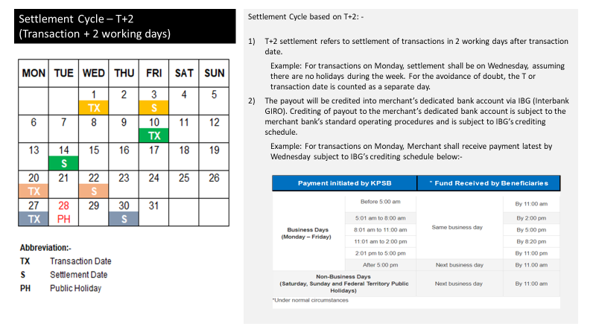

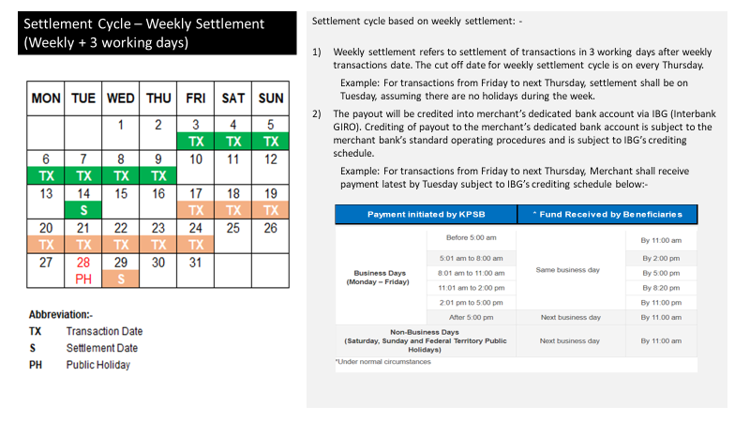

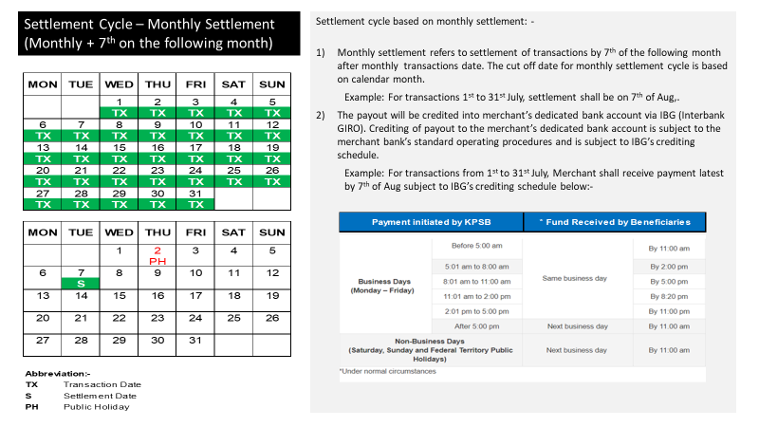

**APPENDIX A**

**ADDITIONAL LIST AND SITES**

|  |  |  |  |  |  |  |  |  |  |  |  |  |
| --- | --- | --- | --- | --- | --- | --- | --- | --- | --- | --- | --- | --- |
| **Payment Services:** | |  | E-Wallet Only | |  | Card Acceptance Only |  | Both E-Wallet & Card Acceptance | | | | |
|  | |  |  | |  |  |  |  | | | | |
| **No.** | **Merchant DBA* Name** | | | **Address** | | | | **PIC Contact Name** | **PIC Contact Number** | **Operating Hours** | **E-Wallet Functionality**  (Static QR, Merchant Scan User, OAT) |
|  |  | | |  | | | |  |  |  |  |
|  |  | | |  | | | |  |  |  |  |
|  |  | | |  | | | |  |  |  |  |
|  |  | | |  | | | |  |  |  |  |
|  |  | | |  | | | |  |  |  |  |
|  |  | | |  | | | |  |  |  |  |
|  |  | | |  | | | |  |  |  |  |
|  |  | | |  | | | |  |  |  |  |
|  |  | | |  | | | |  |  |  |  |
|  |  | | |  | | | |  |  |  |  |
|  |  | | |  | | | |  |  |  |  |
|  |  | | |  | | | |  |  |  |  |
|  |  | | |  | | | |  |  |  |  |
|  |  | | |  | | | |  |  |  |  |
|  |  | | |  | | | |  |  |  |  |
|  |  | | |  | | | |  |  |  |  |

* *DBA – doing business as*