MERCHANT ONBOARDING FORM

SECTION I: DETAILS OF MERCHANT

- Type of Business | ☐ | Sole Proprietor |  | ☐ | Partnership | ☐ |  | Corporation
 | ☐ | Government Entity |  | ☐ | Non-Profit Org. | ☐ |  | Others:
- Company Registered Name
- Company Registration No.
- Domain Name | https://
- Company Registered Address
- Company Business Address
- Merchant Type | ☐ | Direct Merchant |  | ☐ | Sub-Merchant
 | Details of Master Merchant/ Referrer |  | Name:

SECTION II: NAME OF DIRECTOR/ PARTNERS
Director / Partner Name: | NRIC/ Passport No.: | Contact No.:

SECTION III: NAME OF AUTHORISED PERSON
Employee(s) Name: | NRIC/ Passport No.: | Email Address: | Contact No.:

SECTION IV: MERCHANT BANK ACCOUNT INFORMATION
- Bank Name: |  | - Account No:
- Beneficiary Name:
Note: The beneficiary of the account has to be the same name of the company, or business, registered with us . Company will not be paying into any other account other than those stated above. If there is any change to the account details, please provide advance written notice in accordance with the Merchant Terms.

SECTION VI: TERMS AND DECLARATION

  - Unless expressly set out in this Merchant Onboarding Form, all capitalised words not defined herein shall have the same meaning ascribed in the Merchant Terms found within www.kiplepay.com (“kiple Website”). This Merchant Onboarding Form and its Schedule shall be incorporated and form part of the Merchant Terms.

  - In the event of a conflict or inconsistency between the provisions of this Merchant Onboarding Form and other provisions of the Merchant Agreement, the provisions of this Merchant Onboarding Form shall prevail to the extent of such inconsistency.

  - I/We agree to the following: -
- all the information provided in this Merchant Onboarding Form is accurate and complete; and
- We have read, understand and agree to be bound by the Merchant Terms found within kiple Website.

SIGNED FOR AND ON BEHALF OF MERCHANT BY

Company stamp

Name:
Designation:
NRIC/ Passport No.:
Date:

FOR KIPLE OFFICE USE ONLY

Date Received:

Remark:

Processed By  Name:  NRIC/ Passport No.:  Designation: | Approved By  Name:  NRIC/ Passport No.:  Designation:

SCHEDULE I
DETAIL OF SERVICES

SERVICES | Payment Gateway
 | ☐ | FPX Online Payment (B2C) |  |  | ☐ | FPX Online Payment (B2B)
 | ☐ | Local Credit Card |  |  | ☐ | Foreign Credit Card
 | ☐ | Local Debit Card |  |  | ☐ | Kiple Wallet
 | ☐ | WeChat Pay^{1,2} |  |  | ☐ | AliPay^{1,2}
 | ☐ | Boost^{1,2} |  |  | ☐ | Touch 'n Go^{1,2}
 | ☐ | Recurring |  |  | ☐ | One Click Payment
 | ☐ | Others:
 | E-Wallet
 | ☐ | Kiple Wallet |  |  | ☐ | Boost^{1,2}
 | ☐ | Touch 'n Go^{1,2} |  |  | ☐ | GrabPay^{1,2}
 | ☐ | AliPay (CN) ^{1,2} |  |  | ☐ | WeChat (CN)^{1,2}
 | ☐ | WeChat (MY) ^{1,2} |  |  | ☐ | Maybank QRPay^{1,2}
 | ☐ | Razer Pay^{1,2} |  |  | ☐ | Kasih Ibu Smart Selangor
 | ☐ | Perak Prihatin |  |  | ☐ | Kasih Ibu Darul Aman
 | ☐ | Local Debit Card |  |  | ☐ | Local Credit Card
 | ☐ | Others:
 | Complete Appendix A.
 | Card Acceptance Device (CAD)
 | ☐ | Card Terminal³ |  |  | ☐ | Others:
 | Complete Appendix B
KIPLE’S CHARGES | ☐ | Standard |  |  | ☐ | Tier-Based
 | Refer to Schedule III: Charges Schedule.
SETTLEMENT PROCESS

PACKAGES | ☐ | Basic | ☐ | Bronze | ☐ | Silver | ☐ | Gold
 | ☐ | Platinum | ☐ | Others:
EQUIPMENT | ☐ | Kiple Terminal | ☐ | CAD Terminal³ | ☐ | Others: | ☐ | N/A
KIPLEPAY CUSTOMER SUPPORT DETAILS | support@kiplepay.com or 603-8605 3357
FINANCE SUPPORT TEAM EMAIL | finance@kiplepay.com  only if Customer Support cannot handle and only if there is a dispute on the Settlement.

SCHEDULE II
ADDITIONAL OR SPECIAL TERMS AND CONDITIONS

ADDITIONAL OR SPECIAL TERMS AND CONDITIONS

^{1,2} | Settlement cycle is weekly settlement.
^{1,2} | Any charges and/or cost incurred in relation to refund shall be payable by merchant.
³ | Settlement and reporting shall be processed by Card Acceptance Device (CAD) provider.
⁴ | ☐ | One(1) time set-up fee and first year annual fee will be paid by Referrer/Master Merchant to Kiplepay Sdn Bhd.
 | ☐ | One(1) time set-up fee and first year annual fee will be paid directly by Merchant to Kiplepay Sdn Bhd.

SCHEDULE III
CHARGES SCHEDULE

SECTION I: ONBOARDING FEE ⁴
Type of Fee |  | Amount (RM) | Remark
☐ | One Time Setup Fee:
☐ | Bank Processing Fee:
☐ | Annual Renewal Fee:
☐ | Annual Subscription Fee (One Click Payment):

SECTION II: EQUIPMENT ⁴
Type of Terminal |  | Option |  | Quantity | Per Unit Price (RM) | Total Price (RM) | Remark
☐ | Kiple Terminal | ☐ | Loan (Refundable Deposit)
 |  | ☐ | Outright Purchase
☐ | Card Terminal ³ | ☐ | Loan (Refundable Deposit)
 |  | ☐ | 2 Years Advance Rental Fee (RM50 x 24 Months)

SECTION III: KIPLE’S CHARGES (☐ STANDARD)
Payment Gateway
☐ | FPX Online Payment (B2C): |  | ☐ | FPX Online Payment (B2B):
☐ | Local Credit Card: |  | ☐ | Foreign Credit Card:
☐ | Local Debit Card: |  | ☐ | Kiple Wallet:
☐ | WeChat Pay^{1,2}: |  | ☐ | AliPay^{1,2}:
☐ | Boost^{1,2}: |  | ☐ | Touch 'n Go^{1,2}:
☐ | Others:
E-Wallet
☐ | Kiple Wallet: |  | ☐ | Boost^{1,2}:
☐ | Touch 'n Go^{1,2}: |  | ☐ | GrabPay^{1,2}:
☐ | AliPay (CN)^{1,2}: |  | ☐ | WeChat (CN)^{1,2}:
☐ | WeChat (MY)^{1,2}: |  | ☐ | Maybank QRPay^{1,2}:
☐ | Razer Pay^{1,2}: |  | ☐ | Kasih Ibu Smart Selangor:
☐ | Perak Prihatin: |  | ☐ | Kasih Ibu Darul Aman:
☐ | Local Debit Card: |  | ☐ | Local Credit Card:
☐ | Others:
Card Acceptance Device (CAD)
☐ | Debit Card (Domestic): |  | ☐ | Debit Card (Foreign):
☐ | Prepaid Card (Domestic): |  | ☐ | Prepaid Card (Foreign):
☐ | Credit Card (Domestic): |  | ☐ | Credit Card (Foreign):
☐ | EPP 6 Months: |  | ☐ | EPP 12 Months:
☐ | EPP 18 Months: |  | ☐ | EPP 24 Months:
Kiple’s charges is referring to fee per transaction.

SECTION IV: KIPLE’S CHARGES (☐ TIER BASED (Max. 2 Tiers)
Payment Gateway
Transaction Amount
Per Month (RM)
Payment Option
 |  | (e.g: < RM 100,000) | (e.g: >= RM 100,000 > RM 150,000) |  | (e.g: >=RM 150,000)
☐ | FPX Online Payment (B2C):
☐ | FPX Online Payment (B2B):
☐ | Local Credit Card:
☐ | Foreign Credit Card:
☐ | Local Debit Card:
☐ | Kiple Wallet:
☐ | WeChat Pay^{1,2}:
☐ | AliPay^{1,2}:
☐ | Boost^{1,2}:
☐ | Touch 'n Go^{1,2}:
☐ | Others:
Kiple’s charges is referring to fee per transaction.

SCHEDULE III
SETTLEMENT CYCLE SCHEDULE

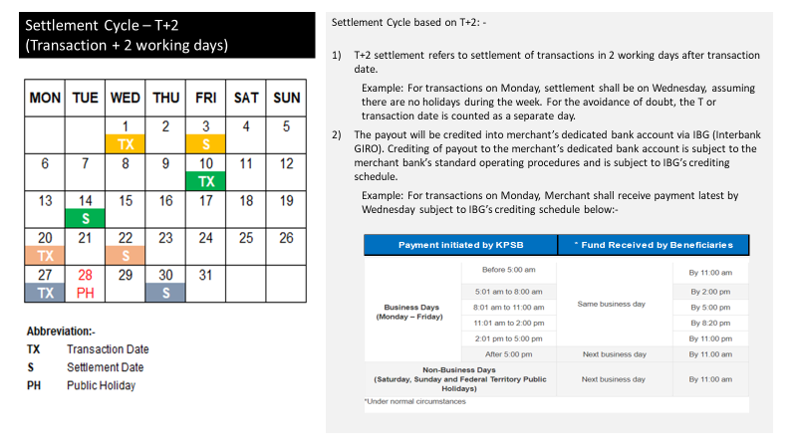

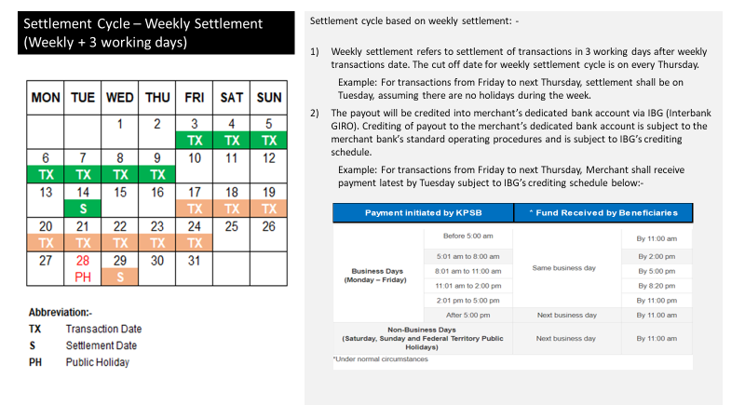

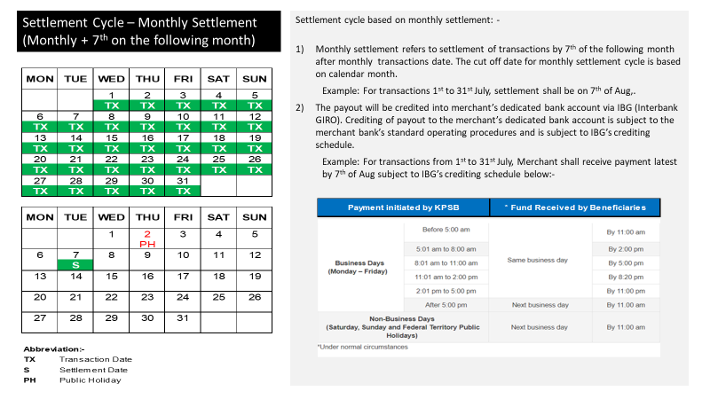

APPENDIX A
ADDITIONAL LIST AND SITES

No. | Merchant DBA* Name | Address | PIC Contact Name | PIC Contact Number | Payment Type  (Static QR, OAT, Other) | Installation Date  (if any)

* DBA – doing business as

APPENDIX B
ADDITIONAL LIST AND SITES

No. | Merchant DBA* Name  (character fixed length: 30) | Address | PIC Contact Name | PIC Contact Number | Installation Date  (if any)

* DBA – doing business as

